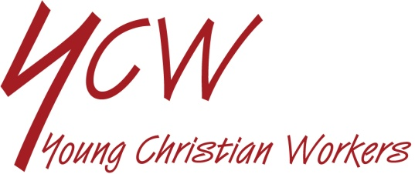

REVIEW OF LIFE ON KEY WORKERS

SEE
- Who are the workers we depend on to live our lives in reasonable comfort and safety, especially during the virus pandemic? Describe what they do.
- Are you one of these workers or do you know anyone who is? What is your/their experience.
- Which workers are most at risk?
- Would you consider doing this kind of work? For what reason?
- Did you join in the applause for NHS and other workers on Thursday evenings? Who were you thinking about? How did you feel about it?

JUDGE
- Which workers are most appreciated? What is the reason for this?
- Should all jobs have equal value?

Read these words of Pope Francis:

“Work is an expression of human dignity, a path of development and of social inclusion. It is a constant stimulus to grow in responsibility and creativity, a protection against the tendency towards individualism and personal gratification. At the same time, it is an opportunity to give glory to God by developing one’s abilities.

Young people do not always have the chance to decide what kind of work they will do, or how their energies and talents will be spent. Because, alongside their own aspirations, abilities and choices, there is the harsh reality of the job market. It is true that you cannot live without working, and that sometimes you have to accept whatever is available, but I ask you never to give up on your dreams, never completely bury a calling, and never accept defeat. Keep seeking at least partial or imperfect ways to live what you have discerned to be your real calling.” (Christus Vivit n.271-2)

- What things help to promote the dignity of work and workers?
- Do the Pope’s words encourage you?

ACT
- How can we show appreciation to those whose work we depend on?
- Could you find out more about job opportunities and kinds of work available?
- Can we encourage those who have no work in any way?

